International Sugar Trade Coalition, Inc.
1054 Thirty-First Street, N.W., Suite 540, Washington, DC 20007
Phone: (202) 965-3449 Fax: (202) 965-4432
www.sugarcoalition.org istc@sugarcoalition.org

May 28, 2012

The Honorable Frank Lucas The Honorable Collin Peterson
House Agriculture Committee House Agriculture Committee
United States House of Representatives United States House of Representatives
Washington, DC 20515 Washington, DC 20515

Dear Chairman Lucas and Ranking Member Peterson:

The International Sugar Trade Coalition (ISTC) represents sugar producers in developing nations in Africa, Asia, the Caribbean, Central America and South America that export sugar to the United States under the U.S. sugar program. ISTC’s members support renewal of the current U.S. sugar program in the 2012 Farm Bill.
Current U.S. sugar policy is important to sugar producers in developing nations because it provides a guaranteed level of access to the U.S. sugar market at fair, predictable prices. Attempts to weaken this policy would not only harm U.S. farmers but also poor growers from developing countries where sugar is a key economic driver.
Opponents of the no-cost U.S. sugar policy have called the U.S. market closed—a statement with which ISTC strongly disagrees. The United States is the world’s biggest importer of sugar, importing 3.7 million tons of sugar from 40 countries—38 of them developing countries—this year alone.
Ending the sugar program would reward only a handful of large food companies and agricultural superpowers like Brazil, while punishing some of the world’s poorest economies. This was what happened when the European Union radically altered its sugar policy, and thereby caused economic harm in developing countries like Guyana, Fiji, Mauritius and Swaziland, where there is no agricultural alternative to sugarcane. Sadly, St, Kitts and Nevis had to stop sugar production altogether after 300 years as a result of the EU’s reforms.
We urge you to preserve the current U.S. sugar program, which operates at no cost to taxpayers, and provides economic opportunity in developing countries around the world. We would be happy to provide any additional information that you would find useful.
Respectfully,
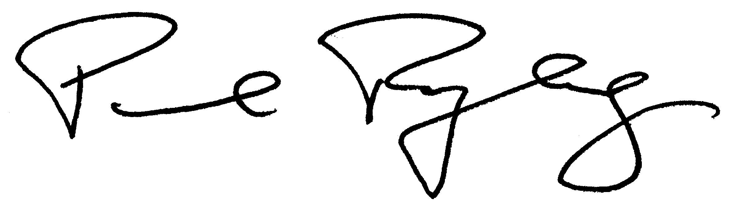
Paul Ryberg
President

cc: Hon. John Boehner
Hon. Eric Cantor
Hon. Nancy Pelosi

